C E R T I F I C A T I O N

TO WHOM IT MAY CONCERN:

This is to certify that _______________________________, ____ years old, _________ is a bonafide resident of this barangay with postal address at ________________________________ St. Bo. Obrero Tondo, Manila, who is known to me as a person of good moral character and has no derogatory record as of this date.

This further certifies that the subject person mentioned above and her immediate family members/relatives are not involved in any illegal activities, not listed in BADAC watchlist or drug personalities and not connected nor member of any left leaning group/organizations.

This certification is being issued for whatever legal purpose it may serve.

Done and issued at the office of the Barangay Chairman, Barangay 192 Zone-17 Dist. II this ____ day of _____________, ______, City of Manila.

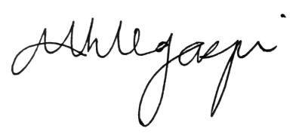

MARIA MAGDALENA H. LEGASPI
Barangay Chairwoman

